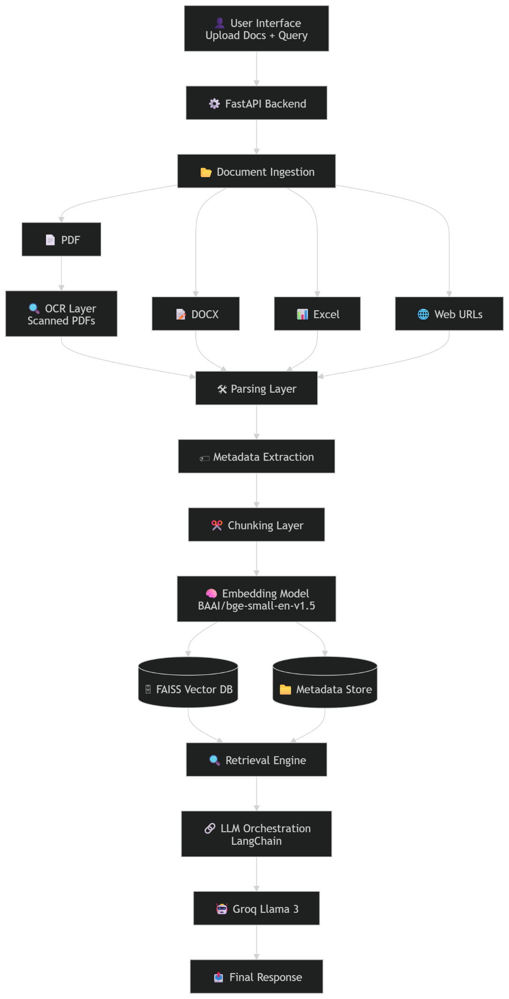
1. Data Processing & Retrieval (RAG)
How will you handle Excel and Web resources specifically to ensure the AI understands the context?
For Excel resources, the system uses pandas and openpyxl to extract structured data such as sheet names, row numbers, column headers, and cell values. Since raw spreadsheet cells lack semantic meaning for embedding models, each row is converted into natural language format before being passed into the chunking and embedding pipeline.
Each Excel row is treated as an independent chunk because rows already represent meaningful units of information. Metadata such as sheet name and row number is stored alongside the chunk to enable accurate citations during retrieval.
For web resources, the system uses Beautiful Soup to scrape webpage content by extracting titles, headings, paragraphs, and relevant body text while removing unnecessary HTML elements such as scripts or ads.
For websites with dynamic JavaScript-rendered content, the system uses Playwright as a fallback to fully render the page before extraction. This ensures that dynamically loaded content is not missed during ingestion.

Explain the chunking strategy and how you will map chunks back to physical locations
(page/row) for citations.
For unstructured documents such as PDFs, DOCX files, and web pages, the system uses LangChain’s RecursiveCharacterTextSplitter with a chunk size of 1000 characters and 200-character overlap. This preserves paragraph boundaries and ensures that contextual information split across sections remains retrievable.
Recursive chunking was chosen over fixed chunking because it prioritizes natural separators such as paragraphs, line breaks, and sentences, reducing the risk of splitting meaningful content mid-sentence.
During ingestion, every chunk is stored along with metadata that maps it back to its original physical source location. For PDFs, this includes page numbers; for DOCX files, section headings; for Excel files, sheet name and row number; and for web resources, URL and section heading.
When retrieval occurs, the selected chunk is returned along with its metadata, allowing the system to generate precise citations such as direct quotes, source file names, and exact locations (page/row/section) in the final response.

How will the &quot;Select/Unselect&quot; feature be implemented at the database level to ensure low latency?
During ingestion, every uploaded document is assigned a unique doc_id, and this identifier is stored alongside each chunk’s embedding and metadata in the FAISS index and metadata store. This creates a clear mapping between chunks and their parent documents.
When users select or unselect documents in the UI, the frontend sends the list of selected doc_ids along with the query request to the FastAPI backend.
Before retrieval, the system first filters the metadata store to narrow the search space to only chunks belonging to the selected documents, instead of searching across all indexed documents. This significantly reduces retrieval latency.
Semantic search is then performed only on the filtered embeddings stored in FAISS, ensuring that the retriever only processes relevant document subsets.

2. System Components
What database and storage solutions do you recommend for high-speed retrieval?
For high-speed semantic retrieval, the system uses FAISS as the primary vector store. It stores document embeddings generated using bge-small-en and enables low-latency nearest-neighbor retrieval.
A separate metadata store (metadata.json in the prototype) is used to store document metadata such as doc_id, file name, page number, section headings, sheet names, and row numbers. This supports citation generation and document-level filtering during retrieval.
For keyword-based retrieval, the system additionally maintains a BM25 index to improve retrieval accuracy for exact-match queries that semantic search might miss.
For larger-scale deployments with thousands of documents, Chroma, Pinecone, or Weaviate can replace FAISS to support persistent storage, metadata filtering, and distributed scaling.

Describe how you would handle user authentication and session management for an
internal tool.
For the prototype, the FastAPI backend can implement JWT-based authentication, where users log in with company credentials and receive a secure access token for subsequent API requests. This ensures that only authorized internal users can upload documents and access the Knowledge Assistant.
For production deployment, the system can integrate with enterprise Single Sign-On (SSO) providers such as Github or Google OAuth to leverage existing organizational authentication infrastructure and avoid maintaining separate credentials.
User sessions can be managed using secure session tokens stored in HTTP-only cookies or token-based authentication with expiration policies.
A relational database such as PostgreSQL can store user profiles, session logs, uploaded document ownership, and audit trails to track which users uploaded or accessed specific resources.
Role-based access control (RBAC) can be implemented to restrict document visibility and actions based on user roles (e.g., admin, analyst, viewer), ensuring sensitive internal documents are only accessible to authorized teams.

The AI Strategy
Which LLM(s) do you recommend and why?
For the current prototype, the system uses Groq hosted Llama 3 70B / Llama 3 8B because it provides extremely low-latency inference while maintaining strong reasoning capabilities for summarization, question answering, and citation formatting. This allows fast responses without requiring heavy local infrastructure. The free tier is also good and has high number of daily queries.

Describe the prompt engineering or “System Instruction” strategy to enforce strict citation formatting.
The system uses a strict system prompt that explicitly instructs the LLM to answer questions only using the retrieved context and prohibits it from using external knowledge. This reduces hallucinations and ensures responses remain grounded in uploaded documents.
The prompt includes a mandatory output format that requires the model to return three components: answer, direct quote, and source location. This ensures every response contains verifiable citations.
Retrieved chunks are passed to the LLM along with their associated metadata such as file name, page number, section heading, or row number, enabling the model to reference exact source locations in its response.
If the retrieved context does not contain enough evidence to support an answer or citation, the prompt instructs the model to return: “Information not found in selected documents.” This prevents unsupported answers and maintains citation reliability.

How will the system handle cases where the answer is not in the selected documents?
The retrieval layer first searches only within chunks belonging to the user-selected documents. If no relevant chunks are retrieved above a similarity threshold from FAISS and BM25, the system identifies that there is insufficient supporting context.
In such cases, the LLM is not allowed to generate an answer using its own pretrained knowledge. The system prompt explicitly instructs the model to respond with “Information not found in selected documents.” when sufficient evidence is unavailable.

4. Cost & Scaling
How does your design minimize “Token Waste”?
The system minimizes token usage by using FAISS and BM25 to retrieve only the top-k most relevant chunks instead of sending entire documents to the LLM. This significantly reduces unnecessary context being passed to the model.
The Select/Unselect document feature further reduces token waste by limiting retrieval to only user-selected documents, preventing irrelevant documents from entering the prompt context.
Chunking is optimized using RecursiveCharacterTextSplitter with controlled chunk sizes and overlap, ensuring chunks are small enough for efficient retrieval while still preserving context.

Briefly explain how the system could scale if the number of documents grew from 40 to
4,000.
At the current scale of 40 documents, FAISS with local metadata storage is sufficient because retrieval happens quickly in-memory with minimal infrastructure overhead.
If the document volume grows to 4,000 documents, the system can migrate from local FAISS storage to distributed vector databases such as Chroma, Pinecone, or Weaviate, which support persistent storage, metadata filtering, and horizontal scaling.

